[insert notes, descriptions of problems you run into, etc]

Background and helpful links:

<https://www.youtube.com/watch?time_continue=5&v=PtCxJykm3Lg> -- shows how to set up interfaces and configure GNS3

**1. Where to get the router image?**

answer: see image Oscar posted on slack in #lab1

for an alternative, see image Beatriz posted.

**2. *Error while executing VMware command: vmrun has returned an error: Unable to connect to host.***

***Error: The specified version was not found***

Solution: Downgrade VMware to 12.5.x (source: <https://gns3.com/qa/error-the-specified-version-was->)

**3. Wondering how to get some topologies going on Linux?** <https://www.youtube.com/watch?v=D3IJ39Glexc>

**4. Getting ImportError: cannot import name ‘idnadata’ (causes [Errno 61] Connection refused)**

Try installing the previous version, specifically installing V2.1.2 worked in my case. It is available on [GitHub](https://github.com/GNS3/gns3-gui/releases). Beatriz: "I found out that error is due to the new version, it affects Mac and Windows computers. Right now I'm using Windows, but I also installed it in my Mac. Using the older version solved the problem in both."

**5. Wondering how to set up GNS3?**

<https://www.youtube.com/watch?v=SY_i_zXxg3s>

if on ubuntu try "sudo apt-get install gns3" - also gns3 has the full list of commands at http://docs.gns3.com/1QXVIihk7dsOL7Xr7Bmz4zRzTsJ02wklfImGuHwTlaA4/

6. JRNunes: "Not sure if anyone ran into this, when I was playing around with two ES routers and tried to make a link, the default slot was in slot 1 so when I tried to connect 0/0 to 0/0, it did not work. I then added the same thing in slot 1 [that was in] slot 0 and was able to make a link. I am not in the main lab portion yet so not sure if it's an instruction that is provided later."

7. **What is site 1 and site 2 in the lab?**

Site 1 = AS 6000 and site 2 = AS 7000

8. **What is ‘do wr’ and why are my ‘do’ commands not working and what console?**

Start your routers (green arrow at top of screen and right click on the router and click “Console”. Hit enter (if prompted or if nothing is happening) and once you get what looks like a terminal input, enter ‘wr’ (no quotes) and it’ll save your router configuration. ‘Do’ seems to not work on my ubuntu so instead of ‘do wr’, I entered ‘wr’ and it did the purpose.

‘do wr’ works in configure mode of console and ‘wr’ works in normal console window.

9. **Use CDP instead of LLDP (per TA Elaine and Matt):**

(Elaine)   
the lines I added in the config files are:

no cdp log mismatch duplex

cdp timer 30

cdp holdtime 120

10. I had other error "**Could not connect to xxx.xxx.xxx.xxx on port 3080: [WinError 10013]".** But after changing the host binding in preferences from xxx.xxx.xxx.xxx to 127.0.0.1, the error disappeared. [Po Yi Chou]

11. Problem: "having problems with connecting the etherswitch routers, previously I put the NM-16ESW card on slot 0 but some stuff didn't work so I deleted everything and started over with the card on slot 1, but when I try to connect the routers it only displays FastEthernet0/x and not FastEthernet1/x,"

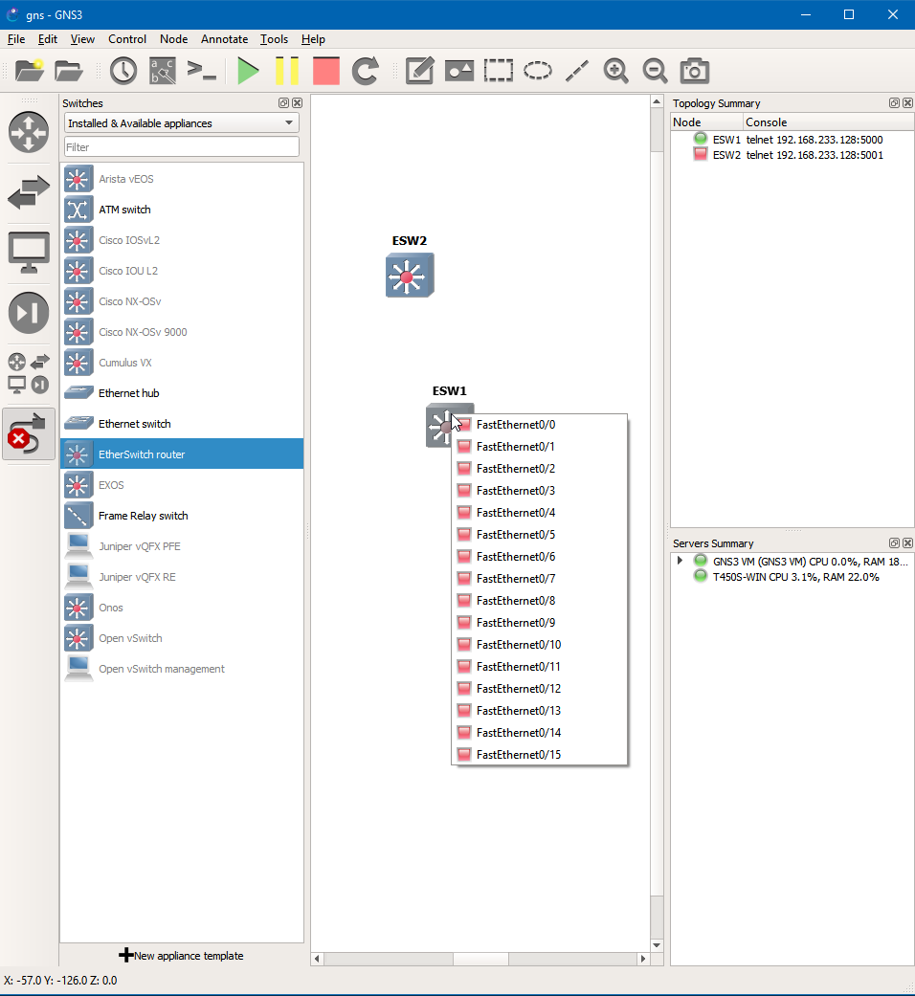

can see the interfaces from the VM console, they just aren't showing up in the GNS3 UI

Solution [Andrew Sun]: "Apparently if I have an empty slot 0 it doesn't see slot 1. I just added a random card into slot 0 and now FastEthernet1/x is showing"

12. **IP Addresses cannot be configured on L2 links**

use the "no switchport" command

13. **In the provided topology, which ASes are customers of which other ASes**

AS 6000 is a customer of AS 8000, AS 8000 is a customer of ASes 7000 and 9000

14. **In the provided topology, what are the dotted circles (eg containing 12.0.0.0/8)?**

These are meant to represent subnets. Configure an interface with 12/8. To test, consider creating a virtual PC hanging off that interface and have it ping some remote host.

15. **Interfaces are configured and showing up in GNS3, but I don't see them when I do "show int"**

Configure the first three slots to all be "NM-1FE-TX". Make sure all three of them are that. Then it will work.

16. **I have a route in "show bgp" but it is not showing up in "show Ip route"**

Check out:

<https://supportforums.cisco.com/t5/other-network-infrastructure/ibgp-not-showing-in-routing-table/td-p/358666>

<http://packetlife.net/blog/2008/nov/19/probable-reasons-bgp-isnt-installing-route/>

17. **How to see neighbors after doing CDP?**In console: show cdp neighbors

18. **Visual OSPF**

<https://www.youtube.com/watch?v=uiTupT0M5LM>

19. **IP address overlap between interfaces**

Generally happens when configuring 10.0.0.x addresses within AS 8000

You have two options:

* Use subnet mask 255.255.255.254, which is a bit sketchy but works
* Change the addresses to something else, EG 10.0.2.x, and use a subnet like 255.255.255.248